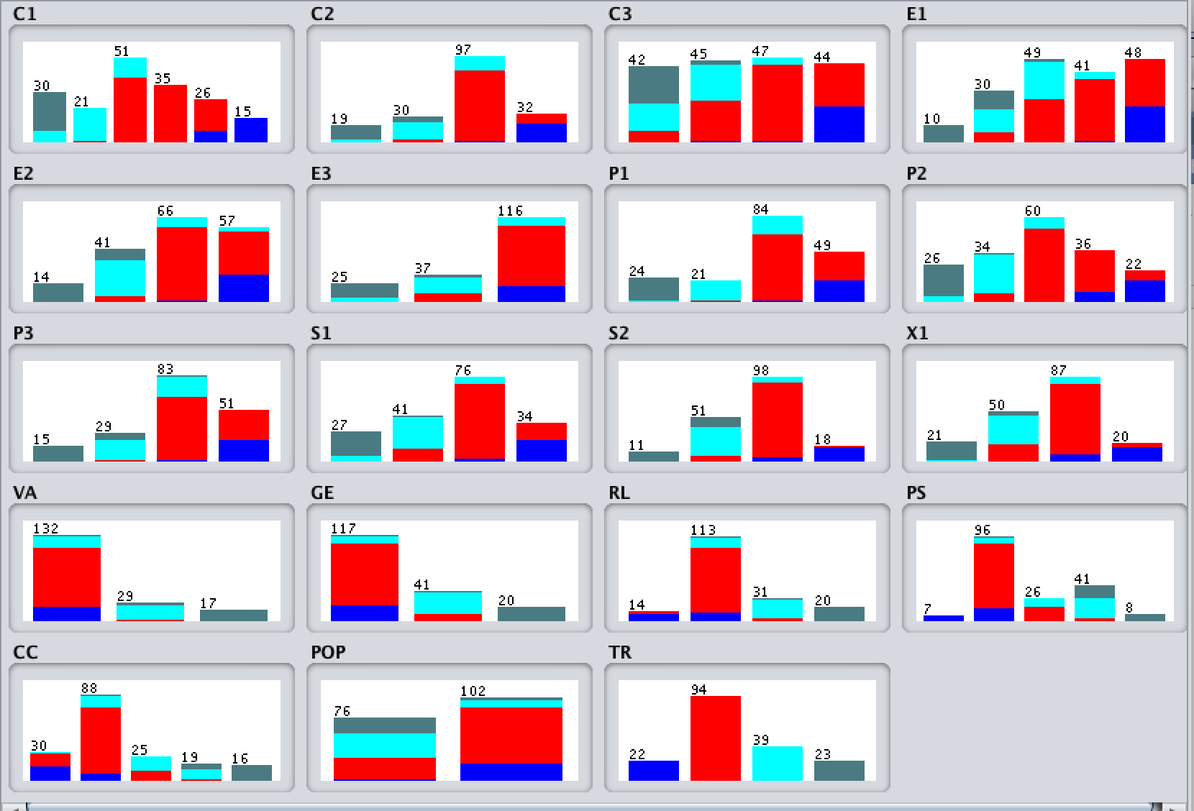

=== Run information ===

Scheme: weka.classifiers.trees.RandomTree -K 0 -M 1.0 -V 0.001 -S 1

Relation: Dataset 2013_x_modified_CSV1-weka.filters.unsupervised.attribute.Remove-R1-2-weka.filters.supervised.attribute.Discretize-Rfirst-last-precision6

Instances: 178

Attributes: 19

C1

C2

C3

E1

E2

E3

P1

P2

P3

S1

S2

X1

VA

GE

RL

PS

CC

POP

TR

Test mode: 10-fold cross-validation

=== Classifier model (full training set) ===

RandomTree

==========

P1 = '(-inf-3.25]'

| RL = '(-inf--1.26949]' : Alert (0/0)

| RL = '(-1.26949-0.290985]' : Sustainable (1/0)

| RL = '(0.290985-1.3973]'

| | S1 = '(-inf-3.4]' : Sustainable (2/0)

| | S1 = '(3.4-5.45]' : Stable (1/0)

| | S1 = '(5.45-8.35]' : Alert (0/0)

| | S1 = '(8.35-inf)' : Alert (0/0)

| RL = '(1.3973-inf)' : Sustainable (20/0)

P1 = '(3.25-5]'

| POP = '(-inf-1.25]' : Stable (17/0)

| POP = '(1.25-inf)'

| | X1 = '(-inf-2.35]' : Alert (0/0)

| | X1 = '(2.35-5.45]' : Stable (3/0)

| | X1 = '(5.45-8.45]' : Warning (1/0)

| | X1 = '(8.45-inf)' : Alert (0/0)

P1 = '(5-8.05]'

| C1 = '(-inf-2.8]' : Stable (2/0)

| C1 = '(2.8-4.85]'

| | P2 = '(-inf-2.55]' : Alert (0/0)

| | P2 = '(2.55-4.45]' : Stable (5/0)

| | P2 = '(4.45-6.95]' : Stable (1/0)

| | P2 = '(6.95-8.65]' : Warning (1/0)

| | P2 = '(8.65-inf)' : Alert (0/0)

| C1 = '(4.85-6.45]'

| | S1 = '(-inf-3.4]' : Alert (0/0)

| | S1 = '(3.4-5.45]'

| | | PS = '(-inf--1.927735]' : Alert (0/0)

| | | PS = '(-1.927735-0.00899]'

| | | | CC = '(-inf--0.950925]' : Alert (0/0)

| | | | CC = '(-0.950925--0.05202]' : Warning (3/0)

| | | | CC = '(-0.05202-0.637025]' : Stable (1/0)

| | | | CC = '(0.637025-1.637555]' : Alert (0/0)

| | | | CC = '(1.637555-inf)' : Alert (0/0)

| | | PS = '(0.00899-0.442335]'

| | | | E1 = '(-inf-2.7]' : Alert (0/0)

| | | | E1 = '(2.7-4.05]' : Alert (0/0)

| | | | E1 = '(4.05-5.85]' : Stable (3/0)

| | | | E1 = '(5.85-7.25]' : Warning (1/0)

| | | | E1 = '(7.25-inf)' : Alert (0/0)

| | | PS = '(0.442335-1.27703]'

| | | | E2 = '(-inf-3.45]' : Alert (0/0)

| | | | E2 = '(3.45-5.75]' : Stable (2/0)

| | | | E2 = '(5.75-7.55]'

| | | | | CC = '(-inf--0.950925]' : Alert (0/0)

| | | | | CC = '(-0.950925--0.05202]' : Alert (0/0)

| | | | | CC = '(-0.05202-0.637025]' : Stable (1/0)

| | | | | CC = '(0.637025-1.637555]' : Warning (1/0)

| | | | | CC = '(1.637555-inf)' : Alert (0/0)

| | | | E2 = '(7.55-inf)' : Stable (1/0)

| | | PS = '(1.27703-inf)' : Alert (0/0)

| | S1 = '(5.45-8.35]'

| | | C2 = '(-inf-2.65]' : Alert (0/0)

| | | C2 = '(2.65-4.95]'

| | | | E1 = '(-inf-2.7]' : Alert (0/0)

| | | | E1 = '(2.7-4.05]' : Stable (1/0)

| | | | E1 = '(4.05-5.85]' : Warning (1/0)

| | | | E1 = '(5.85-7.25]'

| | | | | X1 = '(-inf-2.35]' : Alert (0/0)

| | | | | X1 = '(2.35-5.45]' : Warning (1/0)

| | | | | X1 = '(5.45-8.45]' : Stable (1/0)

| | | | | X1 = '(8.45-inf)' : Alert (0/0)

| | | | E1 = '(7.25-inf)' : Alert (0/0)

| | | C2 = '(4.95-8.45]' : Warning (20/0)

| | | C2 = '(8.45-inf)' : Alert (0/0)

| | S1 = '(8.35-inf)' : Warning (6/0)

| C1 = '(6.45-7.65]' : Warning (22/0)

| C1 = '(7.65-9]'

| | P3 = '(-inf-2.1]' : Alert (0/0)

| | P3 = '(2.1-4]' : Alert (0/0)

| | P3 = '(4-7.55]' : Warning (9/0)

| | P3 = '(7.55-inf)' : Alert (1/0)

| C1 = '(9-inf)' : Alert (0/0)

P1 = '(8.05-inf)'

| S2 = '(-inf-1.85]' : Alert (0/0)

| S2 = '(1.85-3.75]' : Warning (2/0)

| S2 = '(3.75-8.55]'

| | C2 = '(-inf-2.65]' : Alert (0/0)

| | C2 = '(2.65-4.95]' : Alert (0/0)

| | C2 = '(4.95-8.45]' : Warning (18/0)

| | C2 = '(8.45-inf)'

| | | S1 = '(-inf-3.4]' : Alert (0/0)

| | | S1 = '(3.4-5.45]' : Warning (1/0)

| | | S1 = '(5.45-8.35]' : Warning (7/0)

| | | S1 = '(8.35-inf)' : Alert (5/0)

| S2 = '(8.55-inf)' : Alert (16/0)

Size of the tree : 87

Time taken to build model: 0 seconds

=== Stratified cross-validation ===

=== Summary ===

Correctly Classified Instances 167 93.8202 %

Incorrectly Classified Instances 11 6.1798 %

Kappa statistic 0.9032

Mean absolute error 0.0314

Root mean squared error 0.1751

Relative absolute error 9.7381 %

Root relative squared error 43.7058 %

Total Number of Instances 178

=== Detailed Accuracy By Class ===

TP Rate FP Rate Precision Recall F-Measure MCC ROC Area PRC Area Class

0.955 0.006 0.955 0.955 0.955 0.948 0.974 0.917 Alert

0.957 0.071 0.938 0.957 0.947 0.887 0.948 0.930 Warning

0.846 0.022 0.917 0.846 0.880 0.849 0.925 0.825 Stable

1.000 0.006 0.958 1.000 0.979 0.976 0.997 0.958 Sustainable

Weighted Avg. 0.938 0.044 0.938 0.938 0.938 0.898 0.953 0.909

=== Confusion Matrix ===

a b c d <-- classified as

21 1 0 0 | a = Alert

1 90 3 0 | b = Warning

0 5 33 1 | c = Stable

0 0 0 23 | d = Sustainable

=== Run information ===

Scheme: weka.classifiers.trees.RandomForest -P 100 -I 100 -num-slots 1 -K 0 -M 1.0 -V 0.001 -S 1

Relation: Dataset 2013_x_modified_CSV1-weka.filters.unsupervised.attribute.Remove-R1-2-weka.filters.supervised.attribute.Discretize-Rfirst-last-precision6

Instances: 178

Attributes: 19

C1

C2

C3

E1

E2

E3

P1

P2

P3

S1

S2

X1

VA

GE

RL

PS

CC

POP

TR

Test mode: 10-fold cross-validation

=== Classifier model (full training set) ===

RandomForest

Bagging with 100 iterations and base learner

weka.classifiers.trees.RandomTree -K 0 -M 1.0 -V 0.001 -S 1 -do-not-check-capabilities

Time taken to build model: 0.07 seconds

=== Stratified cross-validation ===

=== Summary ===

Correctly Classified Instances 172 96.6292 %

Incorrectly Classified Instances 6 3.3708 %

Kappa statistic 0.9468

Mean absolute error 0.0623

Root mean squared error 0.1407

Relative absolute error 19.3524 %

Root relative squared error 35.1201 %

Total Number of Instances 178

=== Detailed Accuracy By Class ===

TP Rate FP Rate Precision Recall F-Measure MCC ROC Area PRC Area Class

0.955 0.000 1.000 0.955 0.977 0.974 0.999 0.993 Alert

0.989 0.060 0.949 0.989 0.969 0.933 0.995 0.995 Warning

0.897 0.007 0.972 0.897 0.933 0.917 0.995 0.986 Stable

1.000 0.000 1.000 1.000 1.000 1.000 1.000 1.000 Sustainable

Weighted Avg. 0.966 0.033 0.967 0.966 0.966 0.943 0.996 0.994

=== Confusion Matrix ===

a b c d <-- classified as

21 1 0 0 | a = Alert

0 93 1 0 | b = Warning

0 4 35 0 | c = Stable

0 0 0 23 | d = Sustainable

=== Run information ===

Scheme: weka.classifiers.trees.J48 -C 0.25 -M 2

Relation: Dataset 2013_x_modified_CSV1-weka.filters.unsupervised.attribute.Remove-R1-2-weka.filters.supervised.attribute.Discretize-Rfirst-last-precision6

Instances: 178

Attributes: 19

C1

C2

C3

E1

E2

E3

P1

P2

P3

S1

S2

X1

VA

GE

RL

PS

CC

POP

TR

Test mode: 10-fold cross-validation

=== Classifier model (full training set) ===

J48 pruned tree

------------------

S2 = '(-inf-1.85]': Sustainable (11.0)

S2 = '(1.85-3.75]'

| GE = '(-inf-0.137915]'

| | S1 = '(-inf-3.4]': Sustainable (1.0)

| | S1 = '(3.4-5.45]': Stable (4.0)

| | S1 = '(5.45-8.35]'

| | | C2 = '(-inf-2.65]': Warning (0.0)

| | | C2 = '(2.65-4.95]': Stable (3.0)

| | | C2 = '(4.95-8.45]': Warning (7.0/1.0)

| | | C2 = '(8.45-inf)': Warning (0.0)

| | S1 = '(8.35-inf)': Stable (0.0)

| GE = '(0.137915-1.424225]': Stable (25.0)

| GE = '(1.424225-inf)': Sustainable (11.0)

S2 = '(3.75-8.55]'

| C2 = '(-inf-2.65]': Stable (1.0)

| C2 = '(2.65-4.95]'

| | RL = '(-inf--1.26949]': Warning (0.0)

| | RL = '(-1.26949-0.290985]': Warning (3.0)

| | RL = '(0.290985-1.3973]': Stable (3.0)

| | RL = '(1.3973-inf)': Warning (0.0)

| C2 = '(4.95-8.45]': Warning (75.0/2.0)

| C2 = '(8.45-inf)'

| | S1 = '(-inf-3.4]': Warning (0.0)

| | S1 = '(3.4-5.45]': Warning (2.0)

| | S1 = '(5.45-8.35]': Warning (9.0)

| | S1 = '(8.35-inf)': Alert (5.0)

S2 = '(8.55-inf)': Alert (18.0/1.0)

Number of Leaves : 21

Size of the tree : 28

Time taken to build model: 0.02 seconds

=== Stratified cross-validation ===

=== Summary ===

Correctly Classified Instances 163 91.573 %

Incorrectly Classified Instances 15 8.427 %

Kappa statistic 0.8663

Mean absolute error 0.0471

Root mean squared error 0.1794

Relative absolute error 14.6151 %

Root relative squared error 44.7816 %

Total Number of Instances 178

=== Detailed Accuracy By Class ===

TP Rate FP Rate Precision Recall F-Measure MCC ROC Area PRC Area Class

0.955 0.006 0.955 0.955 0.955 0.948 0.993 0.903 Alert

0.957 0.119 0.900 0.957 0.928 0.844 0.947 0.907 Warning

0.769 0.029 0.882 0.769 0.822 0.779 0.923 0.903 Stable

0.957 0.000 1.000 0.957 0.978 0.975 0.978 0.962 Sustainable

Weighted Avg. 0.916 0.070 0.916 0.916 0.914 0.859 0.952 0.913

=== Confusion Matrix ===

a b c d <-- classified as

21 1 0 0 | a = Alert

1 90 3 0 | b = Warning

0 9 30 0 | c = Stable

0 0 1 22 | d = Sustainable